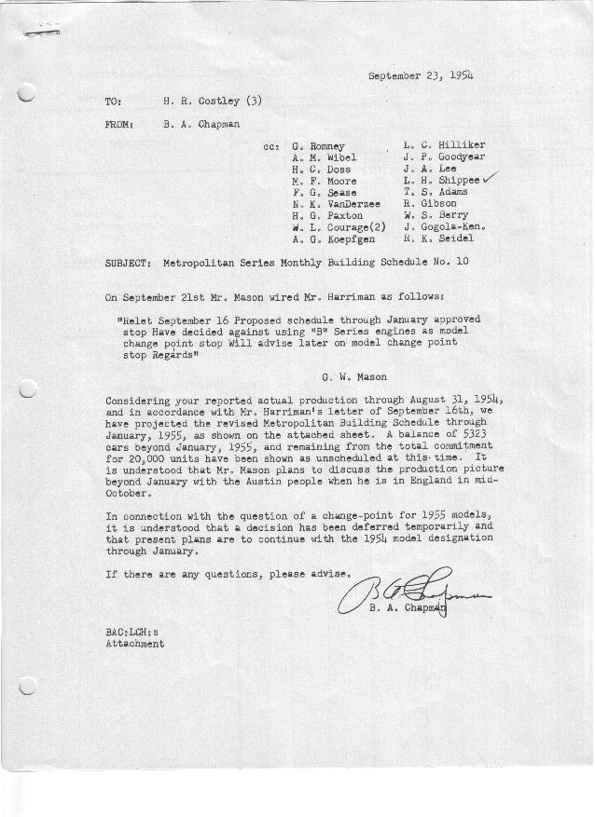

FORM PLAN 68 REV. 9-40-N.K.P PRINTED IN U.S.A

SCHEDULE NO. ______10________ DATE September 21, 1954 MONTHLY BUILDING SCHEDULE APPROVED F. G. Sease & B. A. Chapman (signed)____DATE_ _9-23-54____ ___ REVISION NO. ________________ DATE ________________ PRODUCT APPROVED____ _W. L. Courage (signed) ___________DATE_ _9-23-54____ ___
Metropolitan Series Cars – Austin Motors Co. Ltd., England
DESCRIPTION | BUILT  ACT◻ EST  THRU  8-31-54 | FIRM BUILDING SCHEDULE  (FABRICATED MATERIAL RELEASE) |  |  |  |  |  |  |  |  |  |  |  |  |  |  | TENTATIVE SCHEDULE  (RAW MATERIAL RELEASED) |  |  | GRAND  TOTAL
DESCRIPTION | BUILT  ACT◻ EST  THRU  8-31-54 | MONTH September  DAYS 22 |  |  | MONTH October  DAYS 21 |  |  | MONTH November  DAYS 22 |  |  | MONTH December  DAYS 23 |  |  | MONTH January  DAYS 21 |  |  | Unscheduled  Firm Commitment |  |  | GRAND  TOTAL
DESCRIPTION | BUILT  ACT◻ EST  THRU  8-31-54 | DAILY | MONTH | CUM’L  TOTAL | DAILY | MONTH | CUM’L  TOTAL | DAILY | MONTH | CUM’L  TOTAL | DAILY | MONTH | CUM’L  TOTAL | DAILY | MONTH | CUM’L  TOTAL | DAILY | MONTH | TOTAL | GRAND  TOTAL
Nash
Hard-Top Conv. | 5800 |  | 740 | 6540 |  | 460 | 7000 |  | 260 | 7260 |  | 290 | 7550 |  | 230 | 7780
Soft-Top Conv. | 3771 |  | 0 | 3771 |  | 0 | 3771 |  | 0 | 3771 |  | 0 | 3771 |  | 0 | 3771
Total | 9571 |  | 740 | 10311 |  | 460 | 10771 |  | 260 | 11031 |  | 290 | 11321 |  | 230 | 11551
Hudson
Hard-Top Conv. | 449 |  | 565 | 1014 |  | 600 | 1614 |  | 400 | 2014 |  | 400 | 2414 |  | 400 | 2814
Soft-Top Conv. | 203 |  | 109 | 312 |  | 0 | 312 |  | 0 | 312 |  | 0 | 312 |  | 0 | 312
Total | 652 |  | 674 | 1326 |  | 600 | 1926 |  | 400 | 2326 |  | 400 | 2726 |  | 400 | 3126
Corporation - Total
Hard-Top Conv. | 6249 |  | 1305 | 7554 |  | 1060 | 8614 |  | 660 | 9274 |  | 690 | 9964 |  | 630 | 10594 |  | 4406 |  | 15000
Soft-Top Conv. | 3974 |  | 109 | 4083 |  | 0 | 4083 |  | 0 | 4083 |  | 0 | 4083 |  | 0 | 4083 |  | 917 |  | 5000
Grand Total | 10223 | 64 | 1414 | 11637 | 50 | 1060 | 12967 | 30 | 660 | 13357 | 30 | 690 | 14047 | 30 | 630 | 14677 |  | 5323 |  | 20000
Over/(Under) Sched. #9 | (166) |  | (202) | (368) |  | (200) | (568) |  | (660) | (1228) |  | (690) | (1918) |  | (630) | (2548)

